**MOTOR INSURANCE**

(EVIDENCE DOCUMENT)

**EVIDENCE 1: RECOMMENDED PLAN ALLOCATION**

1)First the Agent log in through the AGENT portal with the credentials

And creates the case with the help of Get Vehicle Insurance button.

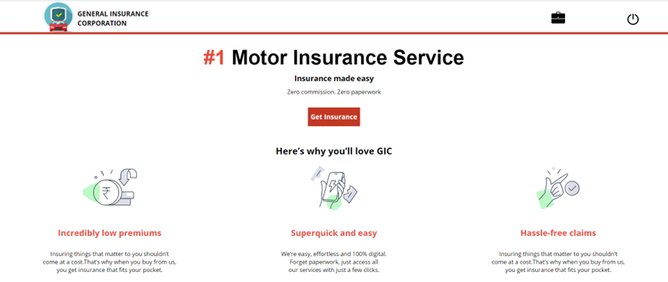

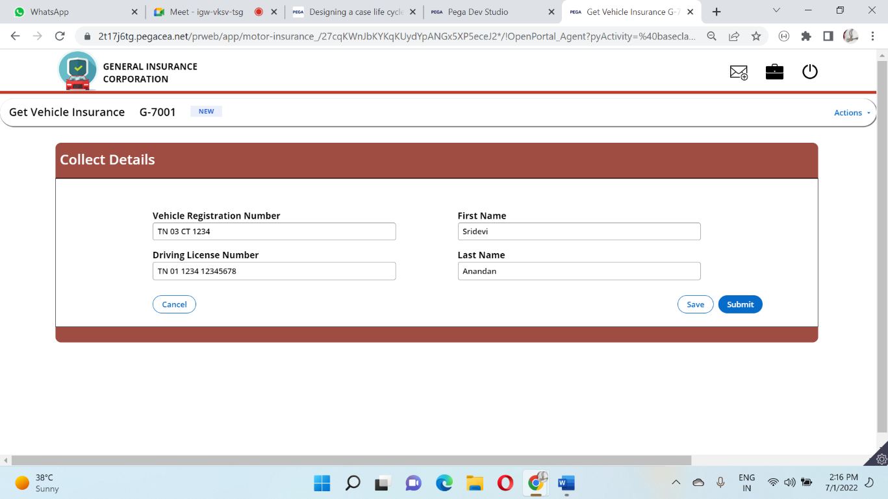

2)After Agent entering the details the duplication check will happen

3)Then the user fills the multistep form, Placeholders are given at appropriate places.

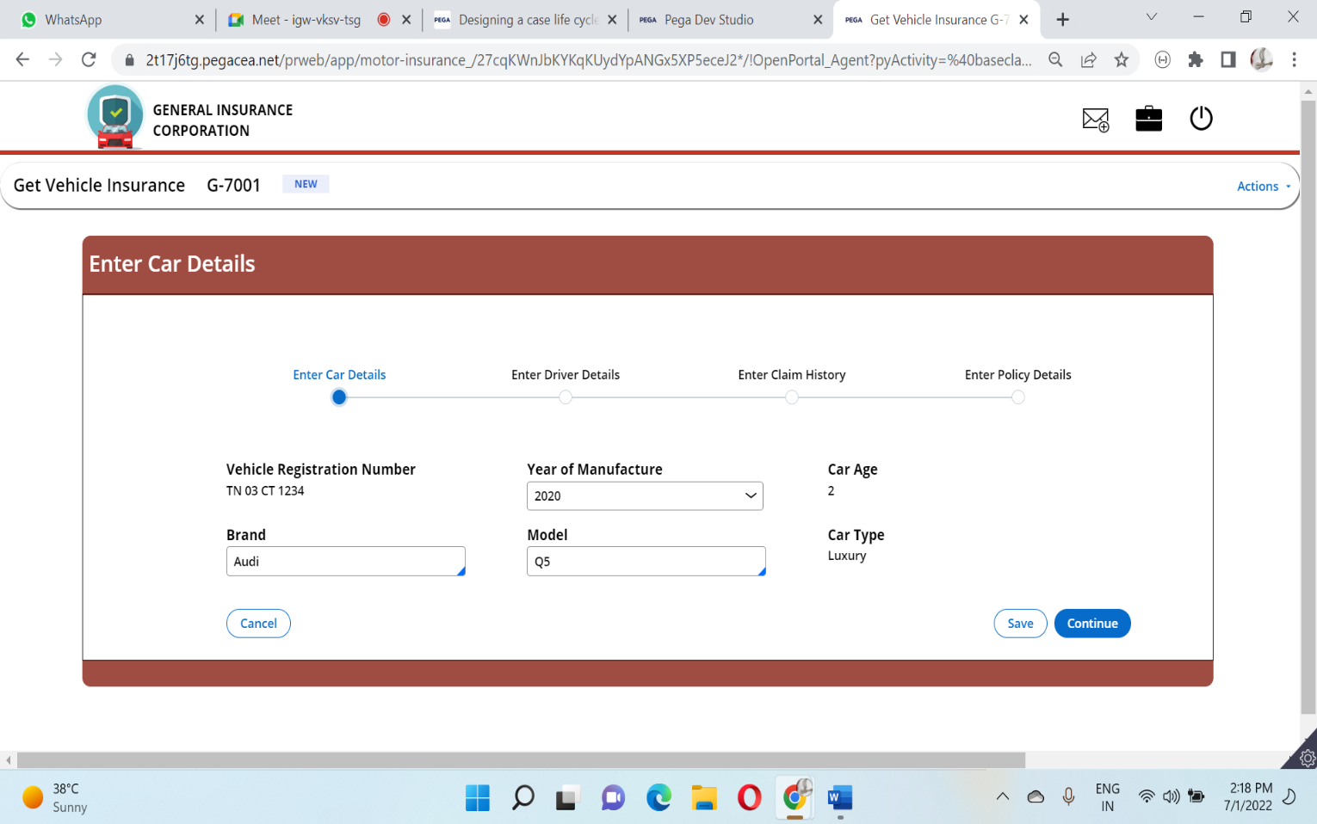

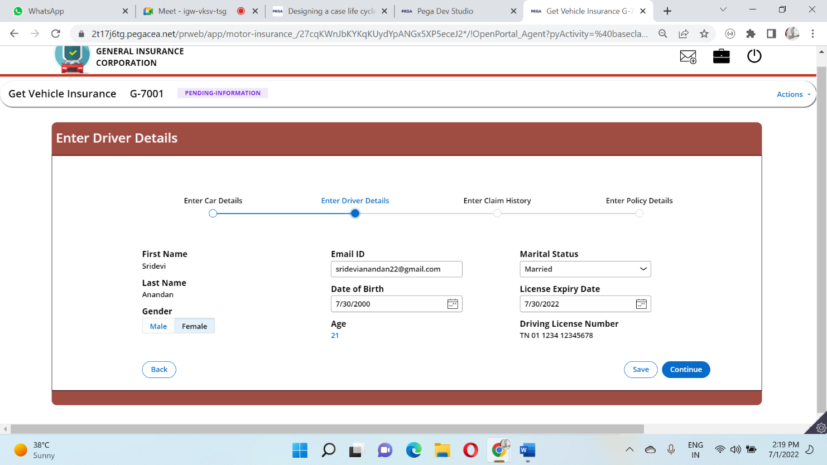

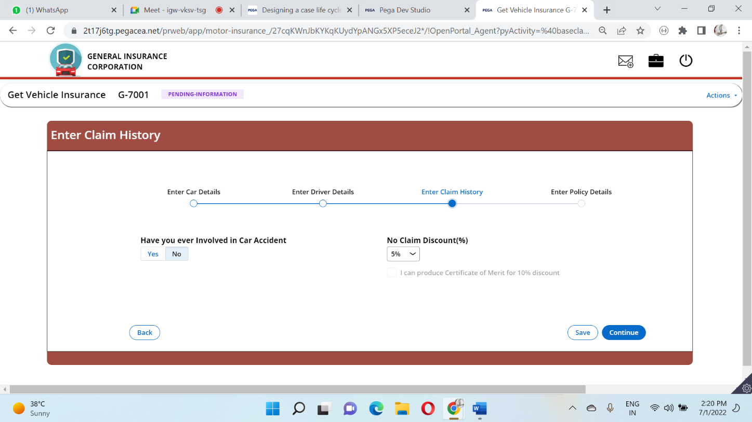

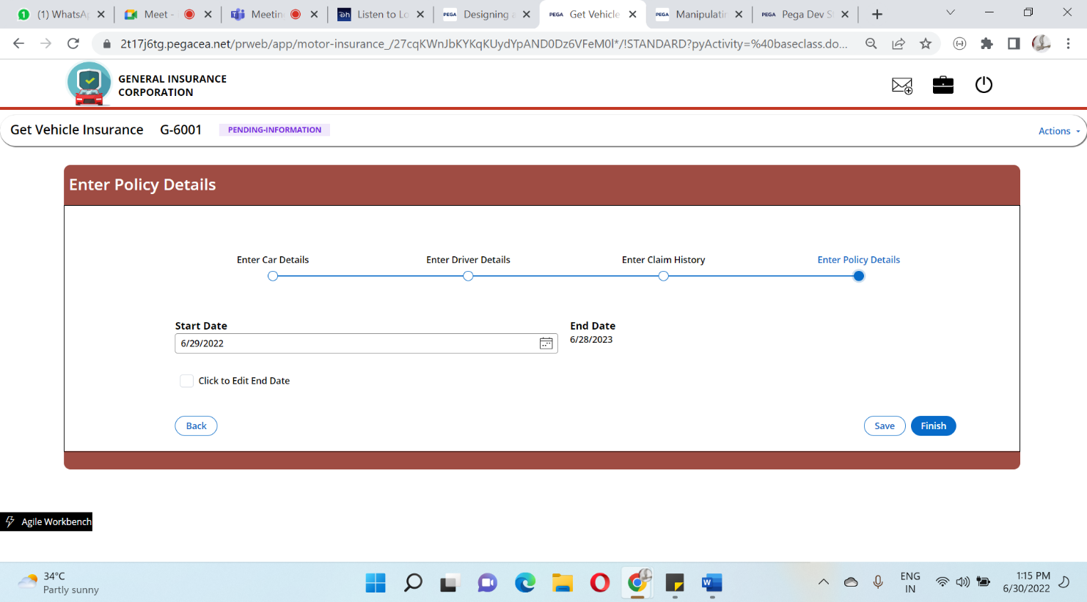

4)In the choose plan step the Agent is presented with a Tab Layout where he can see the plan recommended to him and Eligible Plans

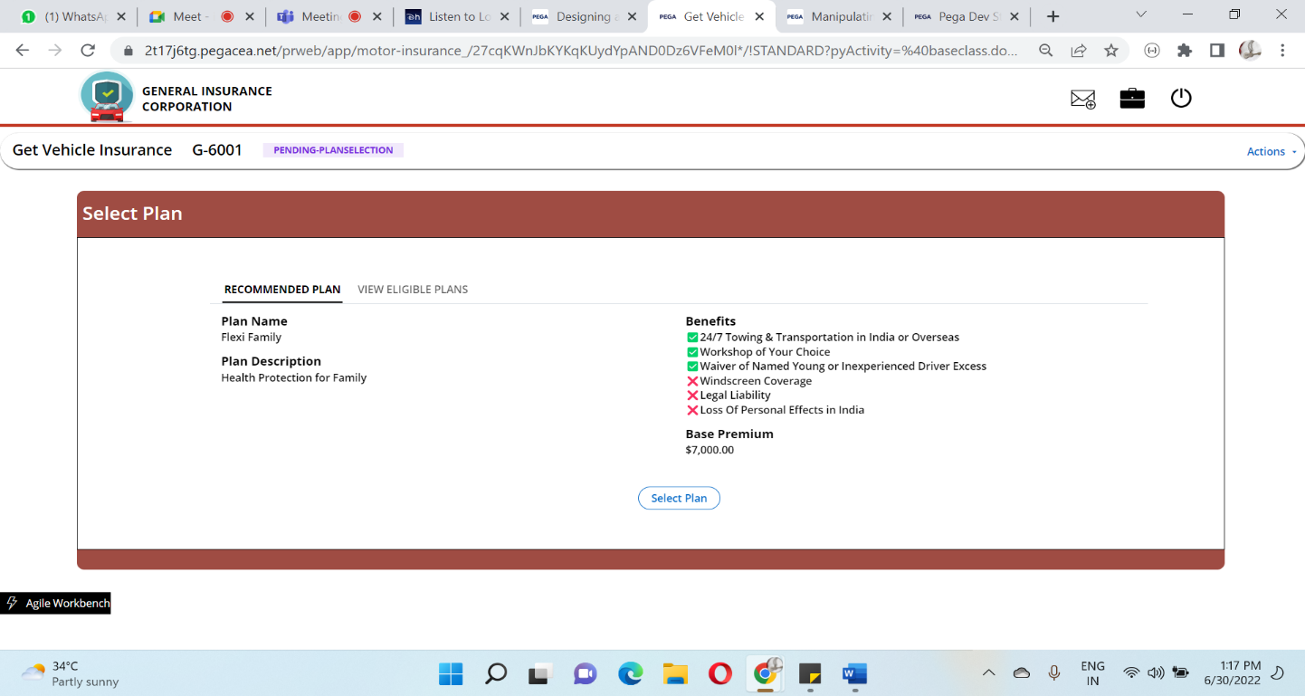

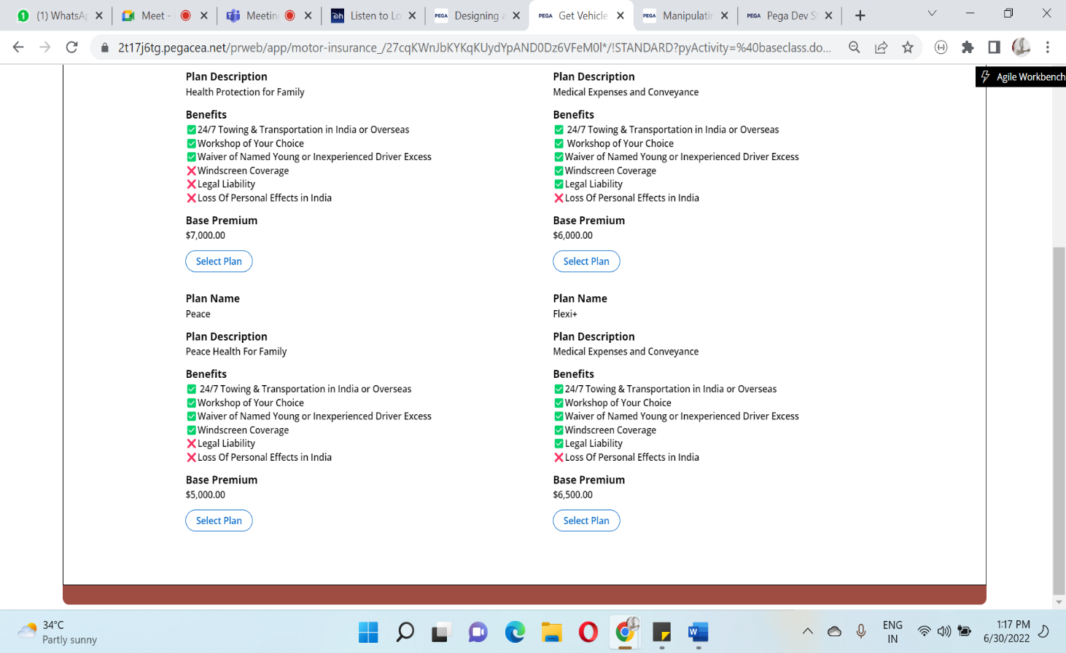

5)After selecting the Plan, it takes the user to the confirm plan step where the Risk amount, discount amount, final premium will be calculated, Agent can approve or reject the request.

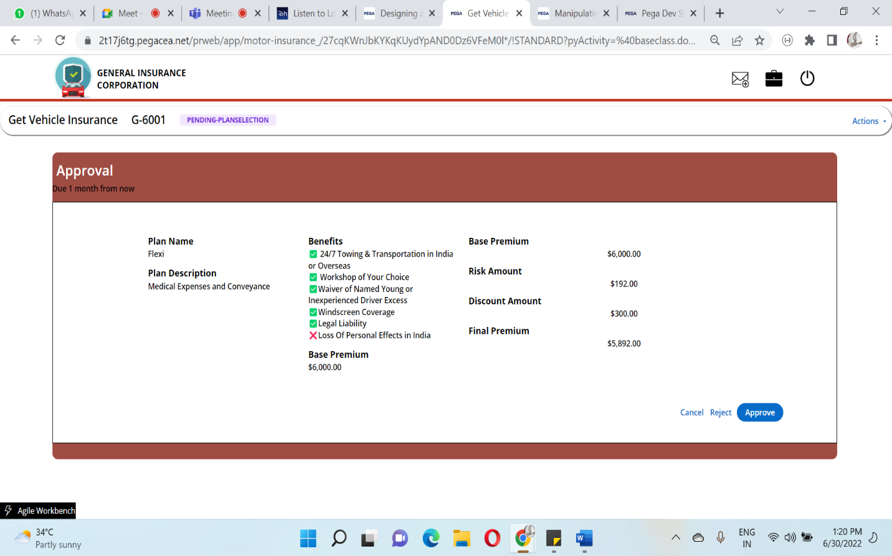

6)User can fill the additional information in a tab layout

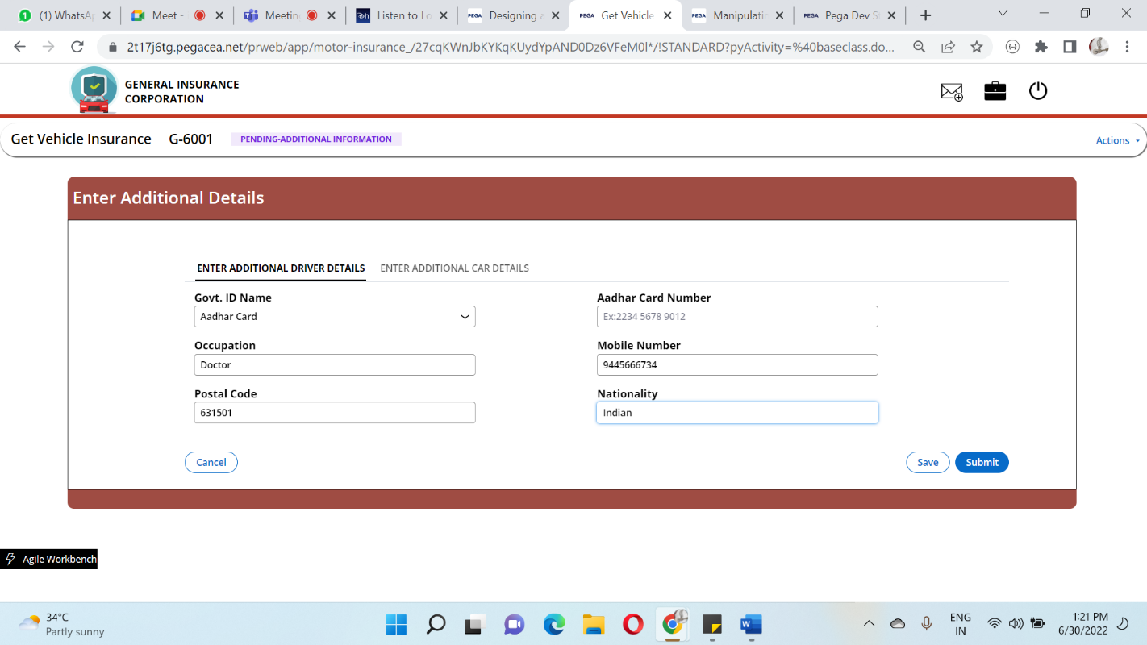

7)The user has to accept the Terms and Conditions to move to the Payment

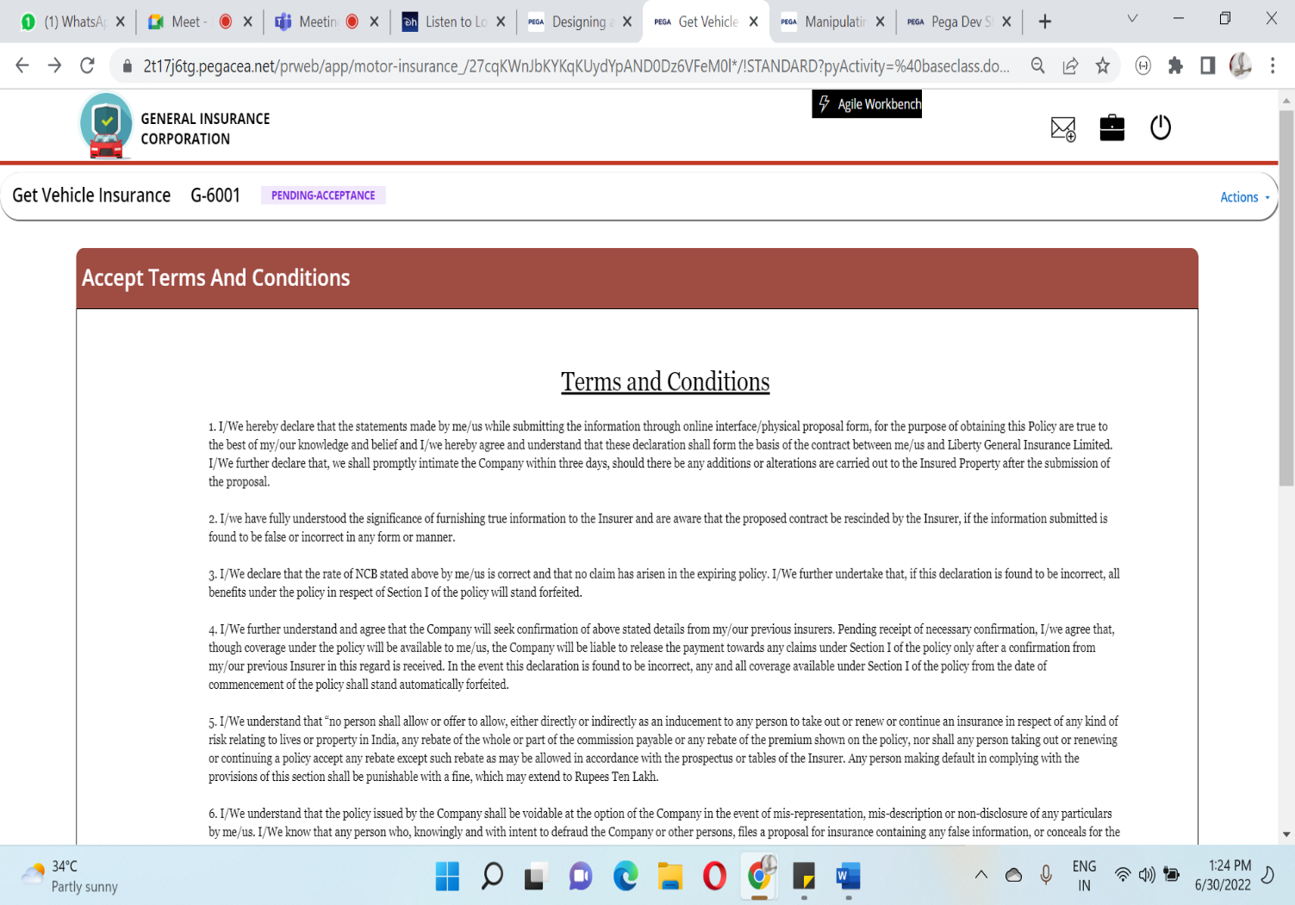

8)In the Complete policy payment Stage user can pay the amount by clicking the Pay now Button

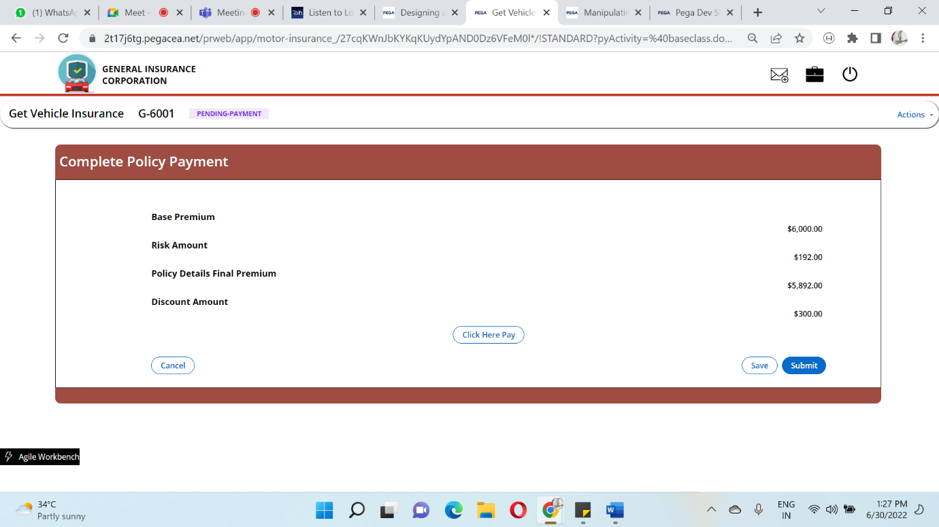

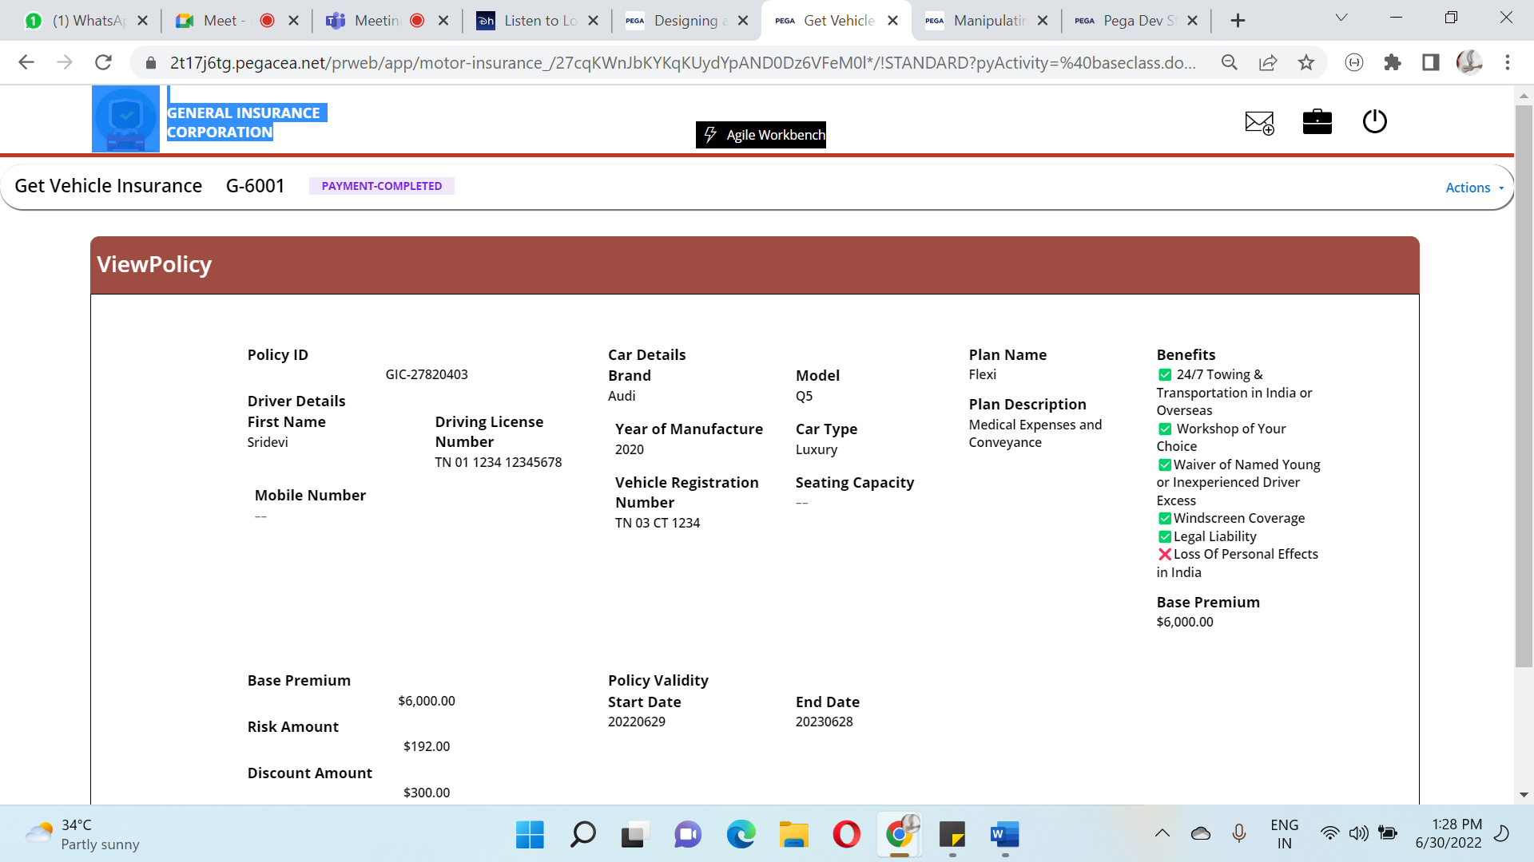

9)Now the Case status will be changed to **Resolved-Completed** as the case resolves successfully.

**CASE ATTACHMENTS:**

Policy Confirmation Mail:

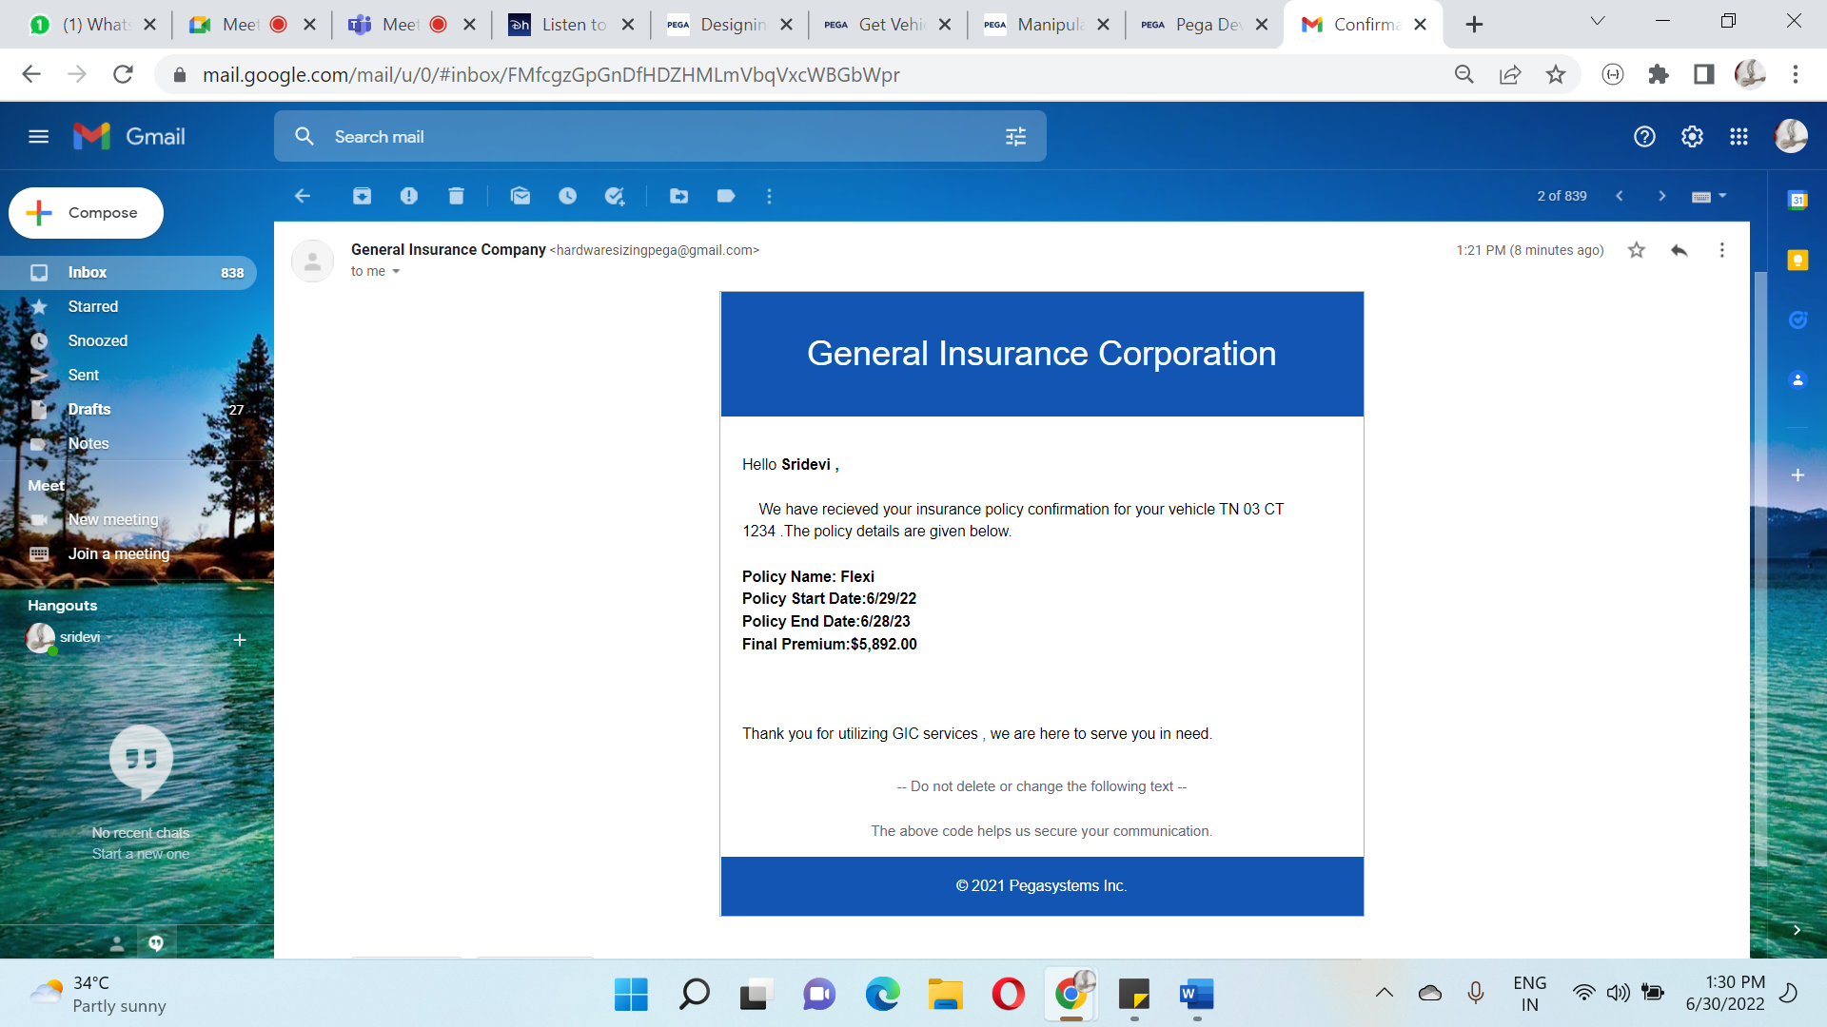

Policy Payment Confirmation Mail:

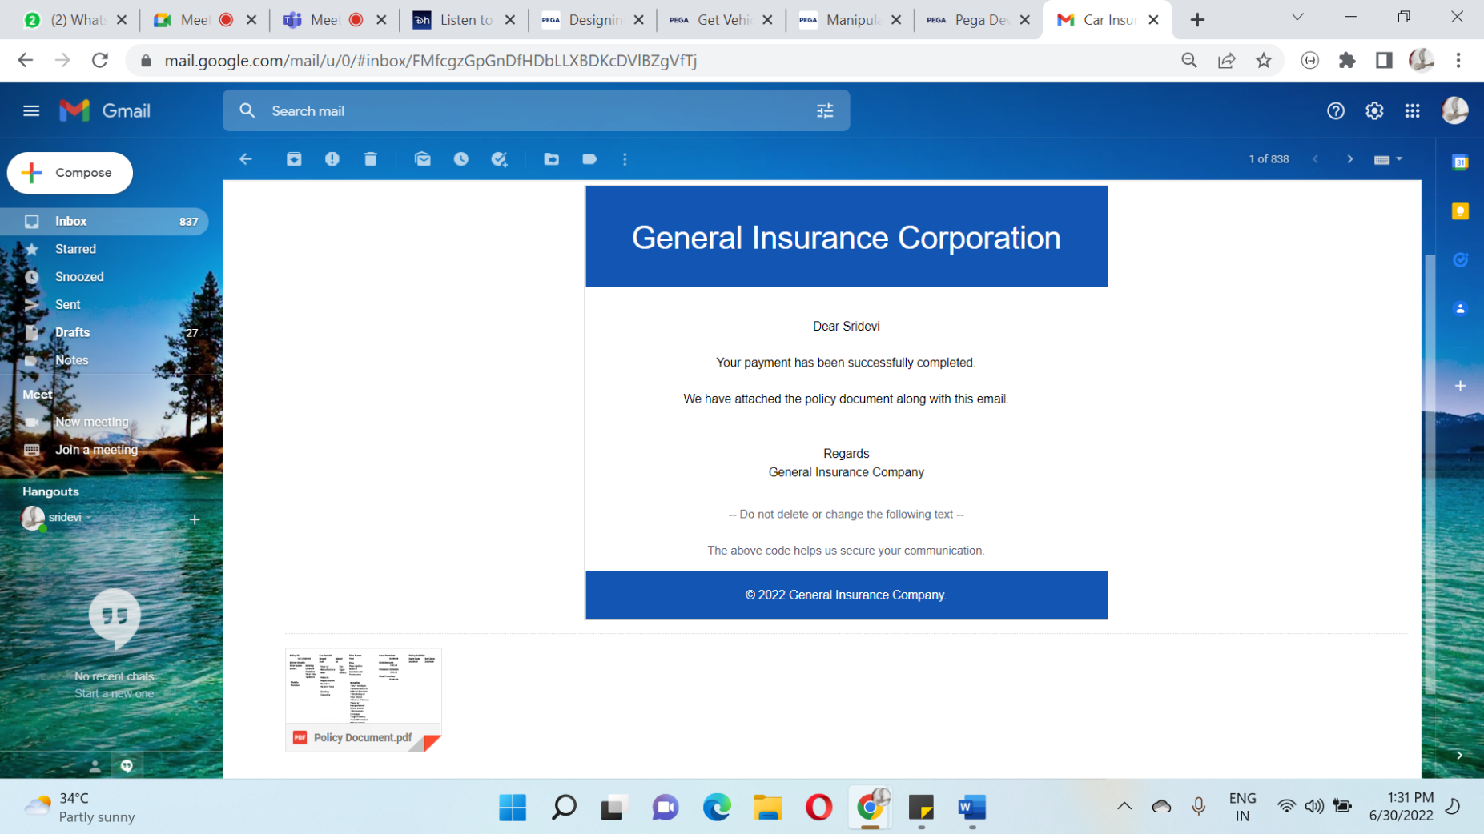

**EVIDENCE 2: UNDERWRITER REVIEW**

1)First Login through the Agent portal, As mentioned in the evidence one duplication check will happen after entering the collect details then agent need to fill the details in the data collection multistep form.

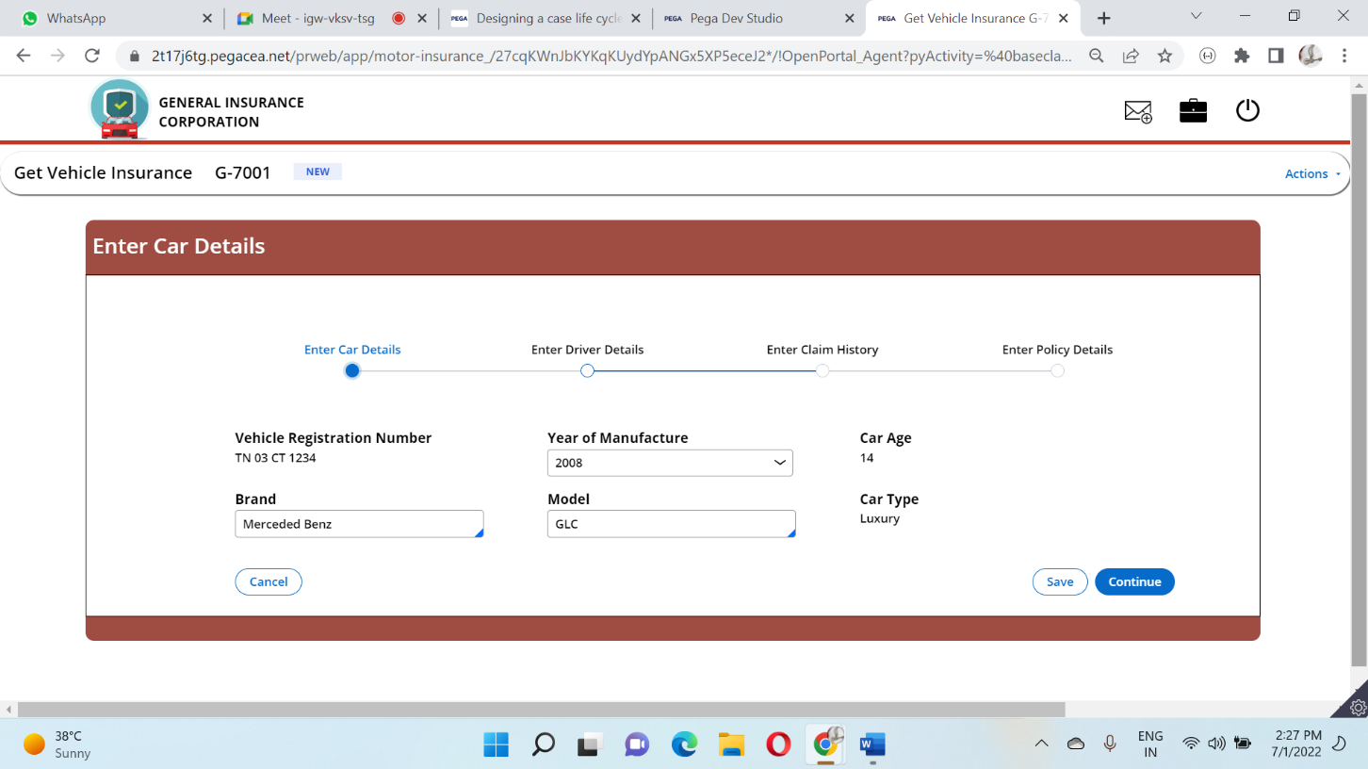

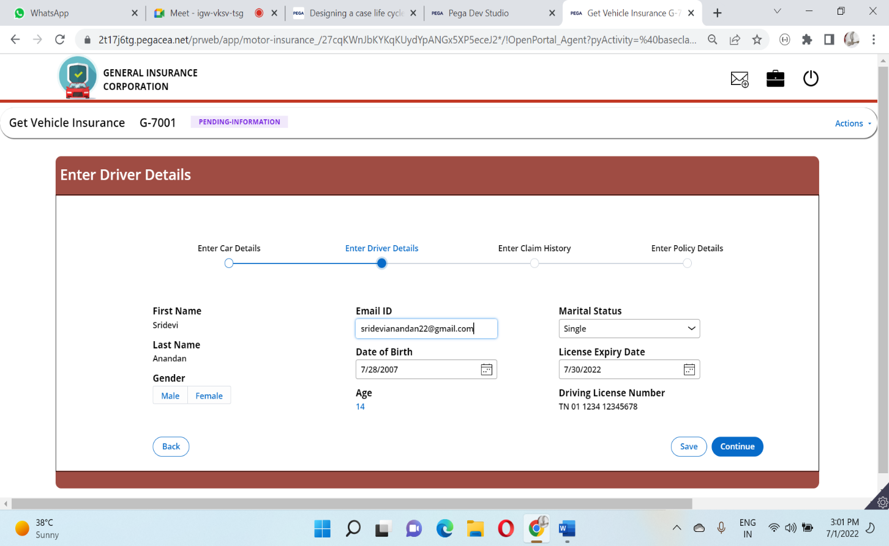

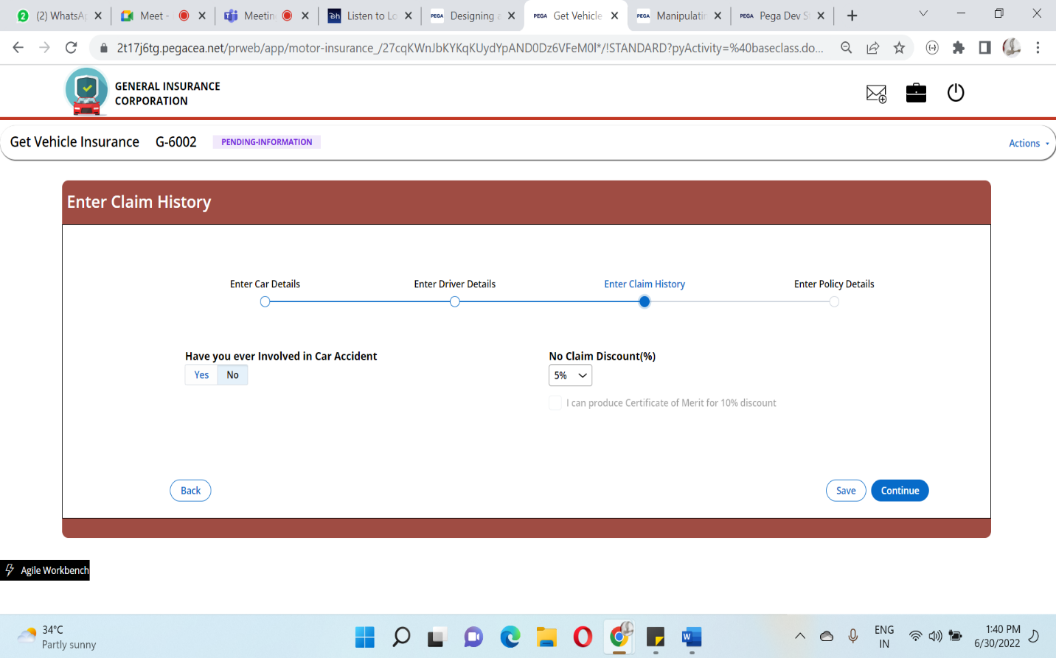

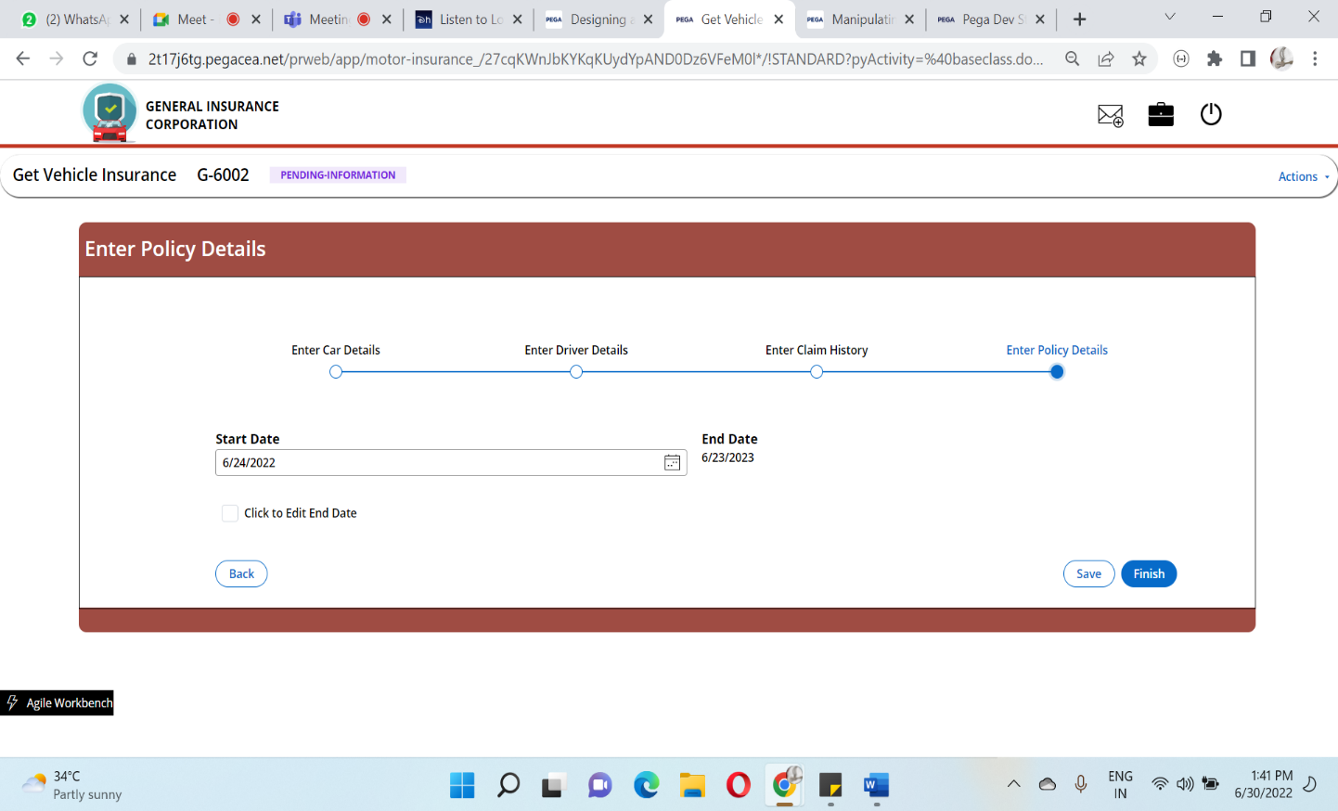

2) It will route to the Underwriter based on the When Condition and Note is provided to the agent regarding the case is routed to the Underwriter.

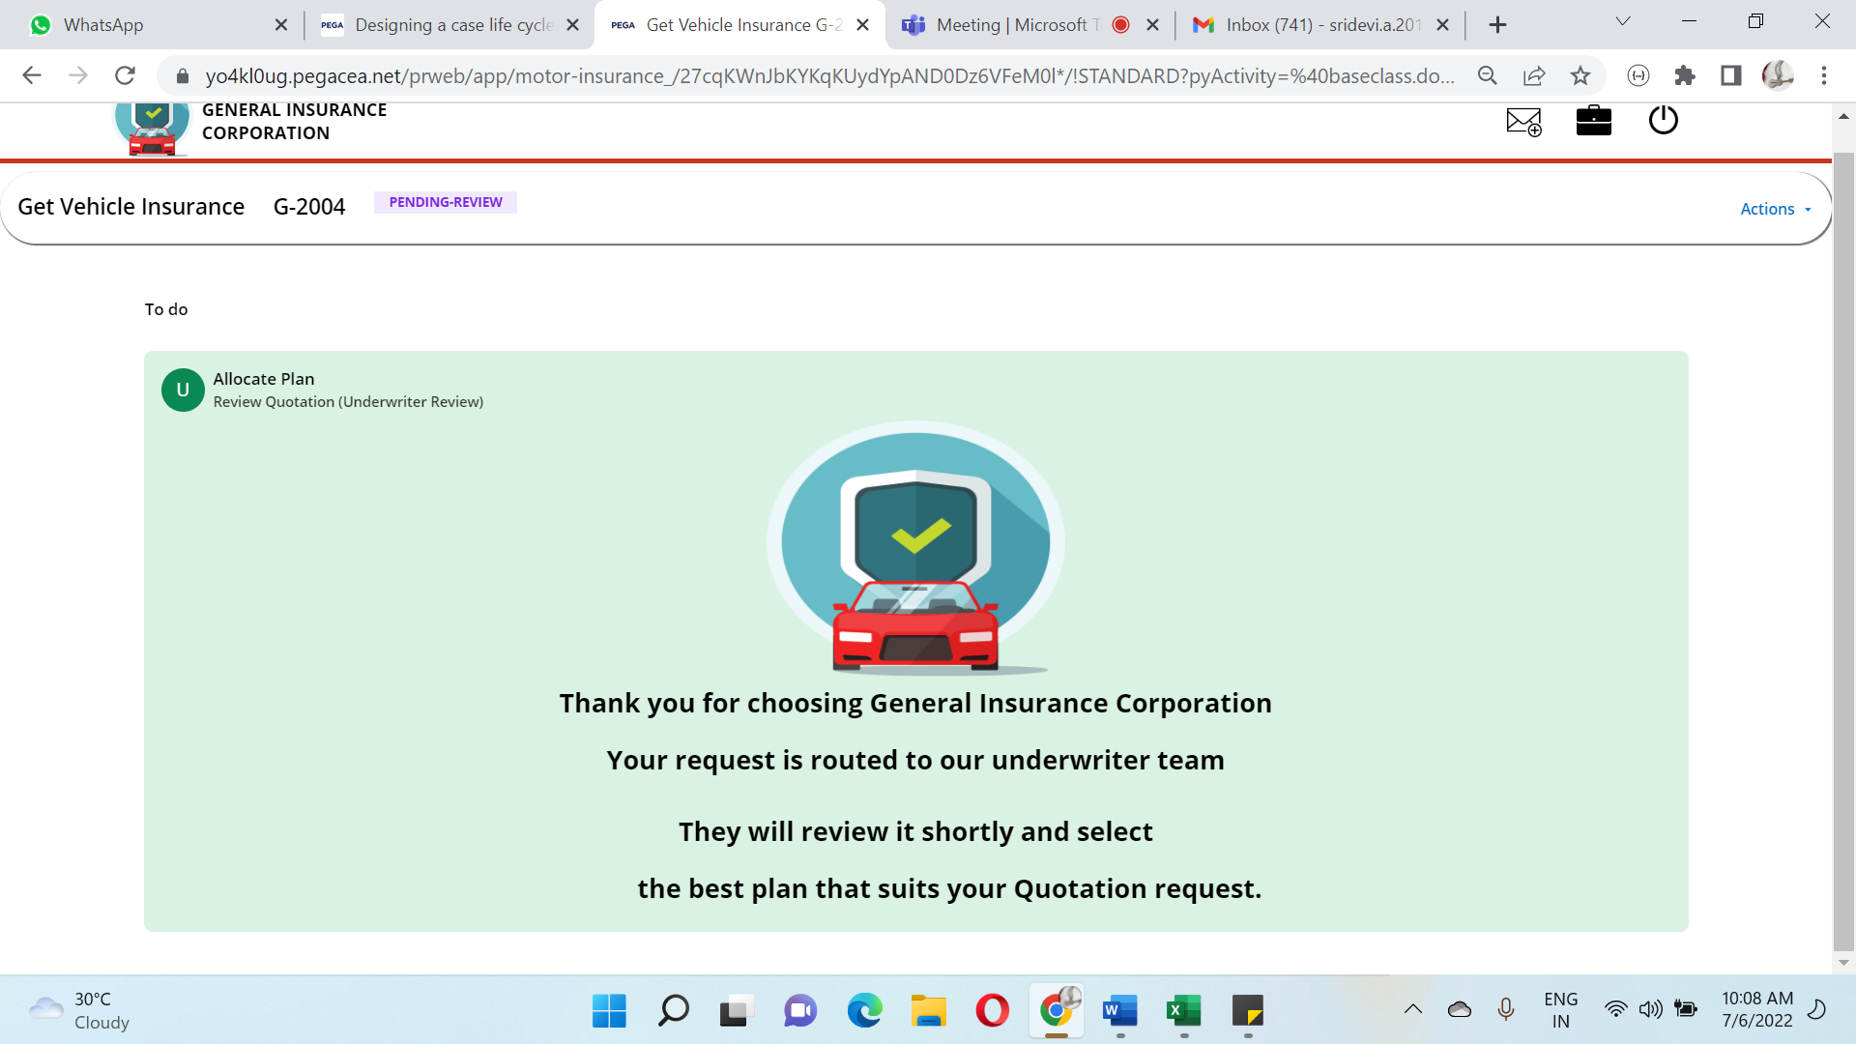

3)Log in through the Underwriter credentials, In the Work queue column, we can see the cases routed.

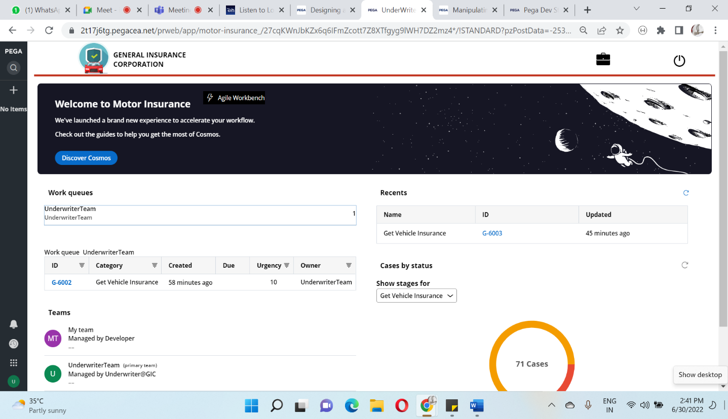

4) Underwriter can review the details of the Agent in a Tab layout and allocate a suitable plan to the Agent

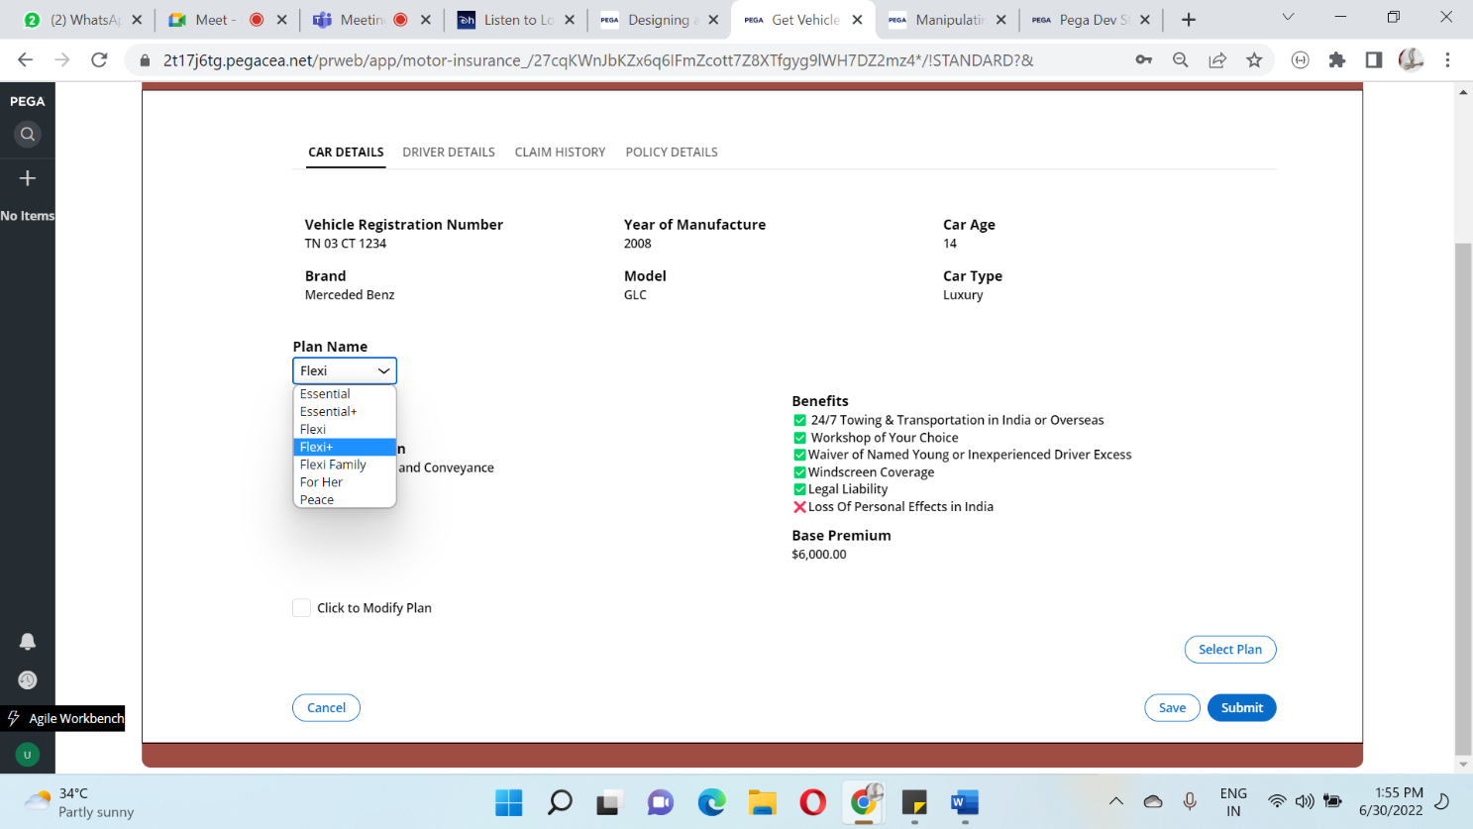

5)Underwriter will select the most suitable plan for the user and modify the existing plan according to the requirement.

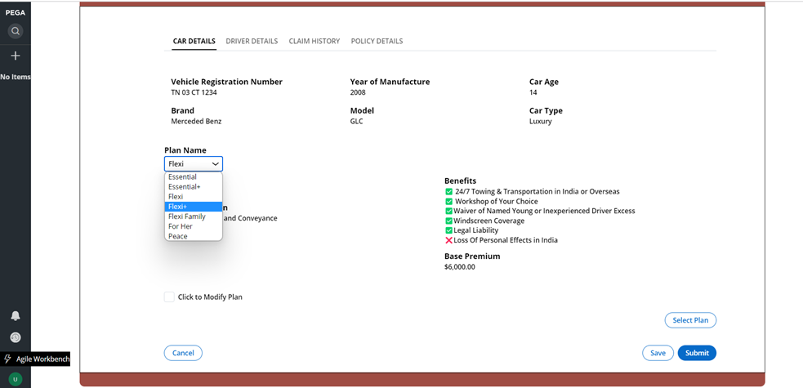

6)It routed back to the agent for confirmation

7)The Agent can approve or reject the plan quoted by the Underwriter

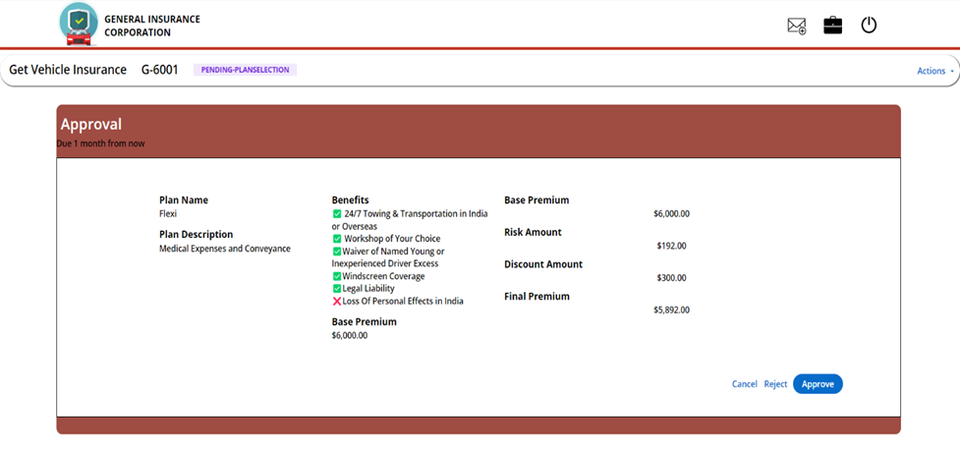

8)After approving the he has to accept the T & C

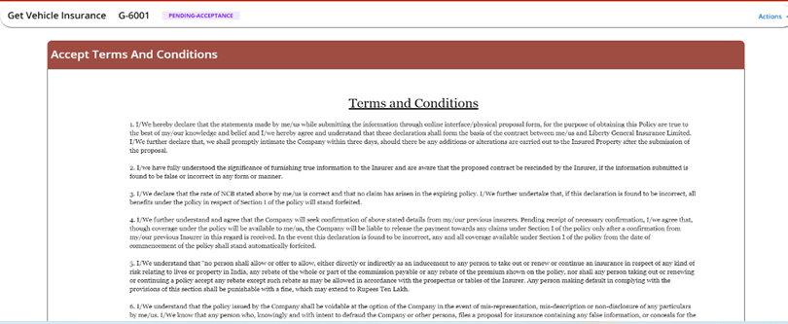

9)By click on the payment button he will directed to the payment gateway after success full payment, the case will resolve.

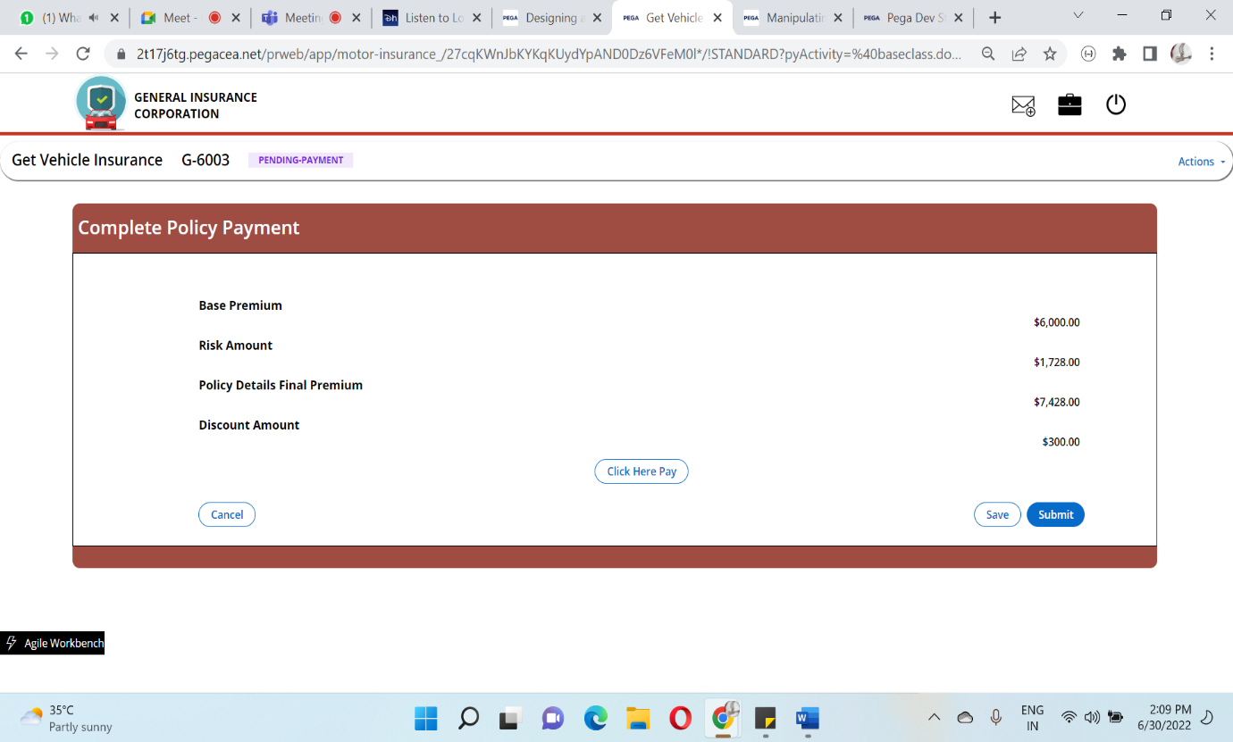

**CASE ATTACHMENTS:**

Underwriter Review Completion

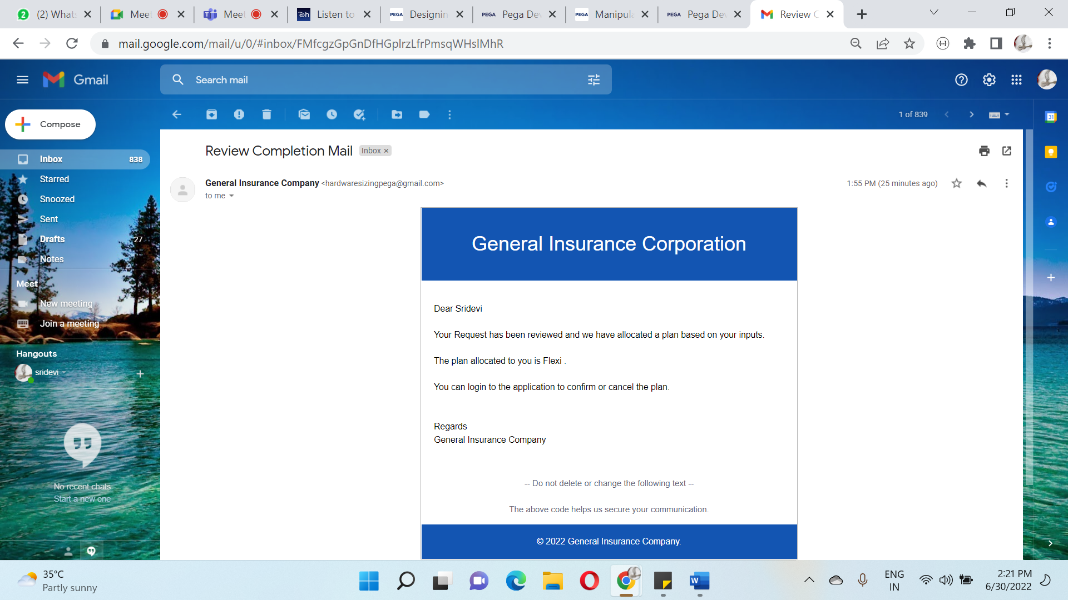

Policy Confirmation Mail:

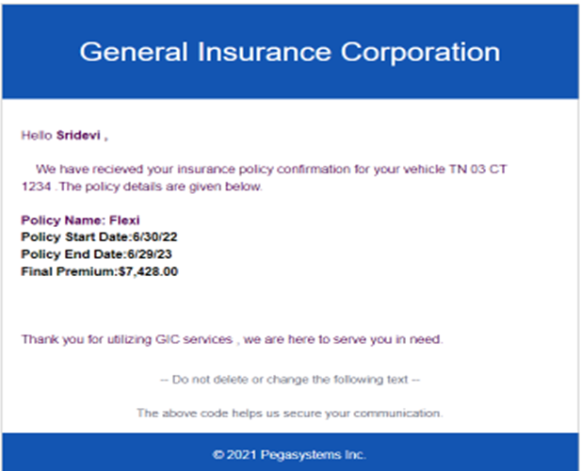

Payment Confirmation Mail:

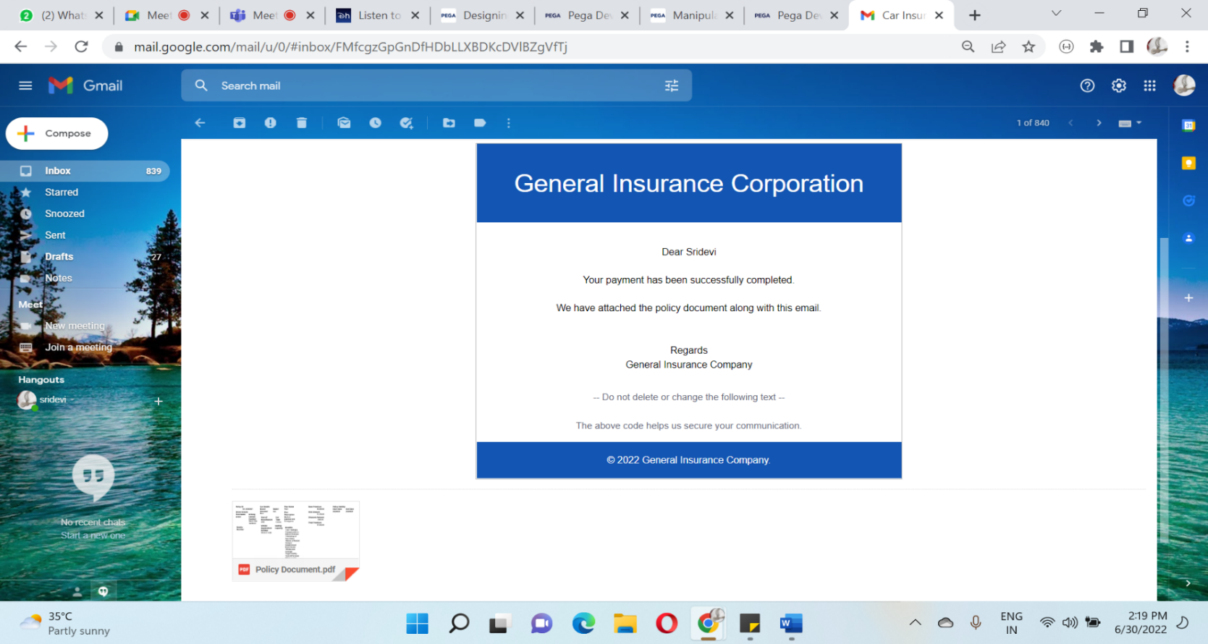

**EVIDENCE 3: AUTOMATIC REJECTION**

1)First Login through the Agent portal and fill in the data collection multistep form

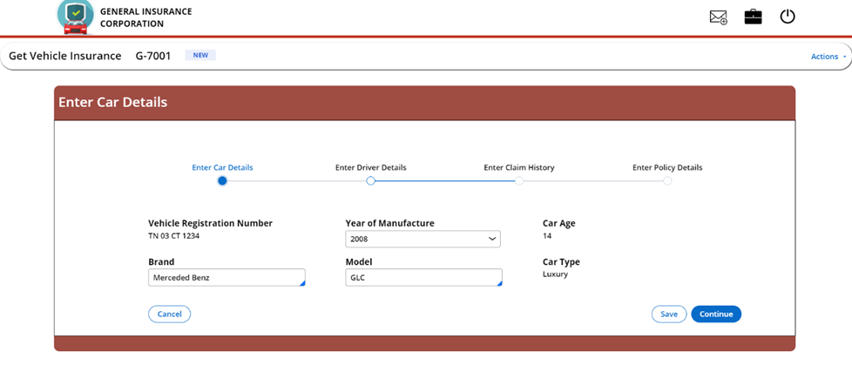

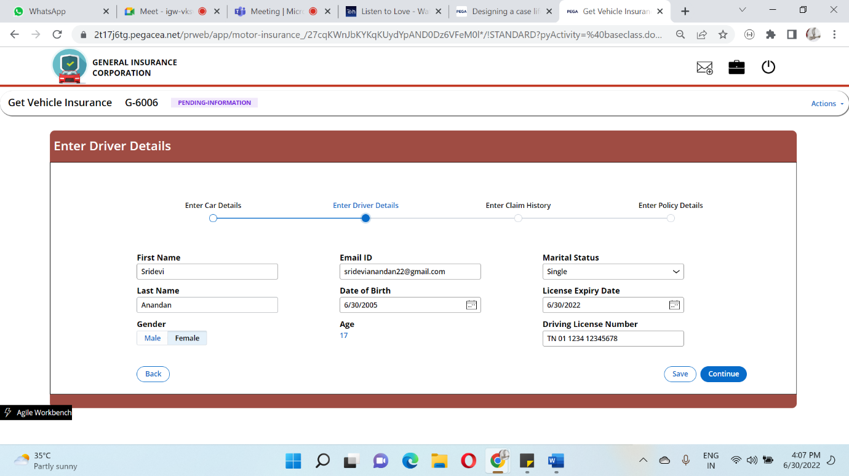

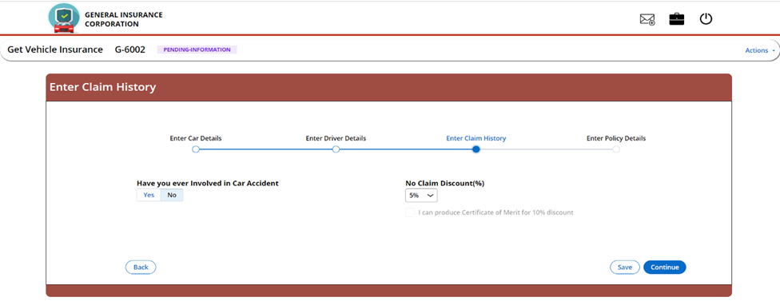

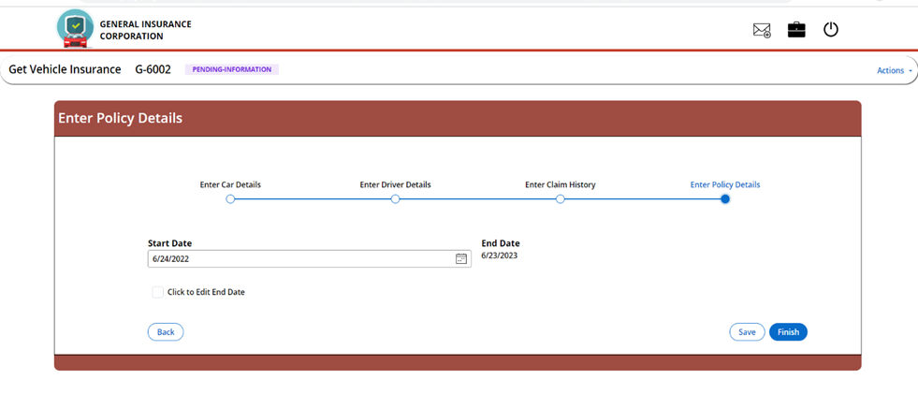

2) After Submission , The case will be automatically rejected and a confirmation note is also given to End user

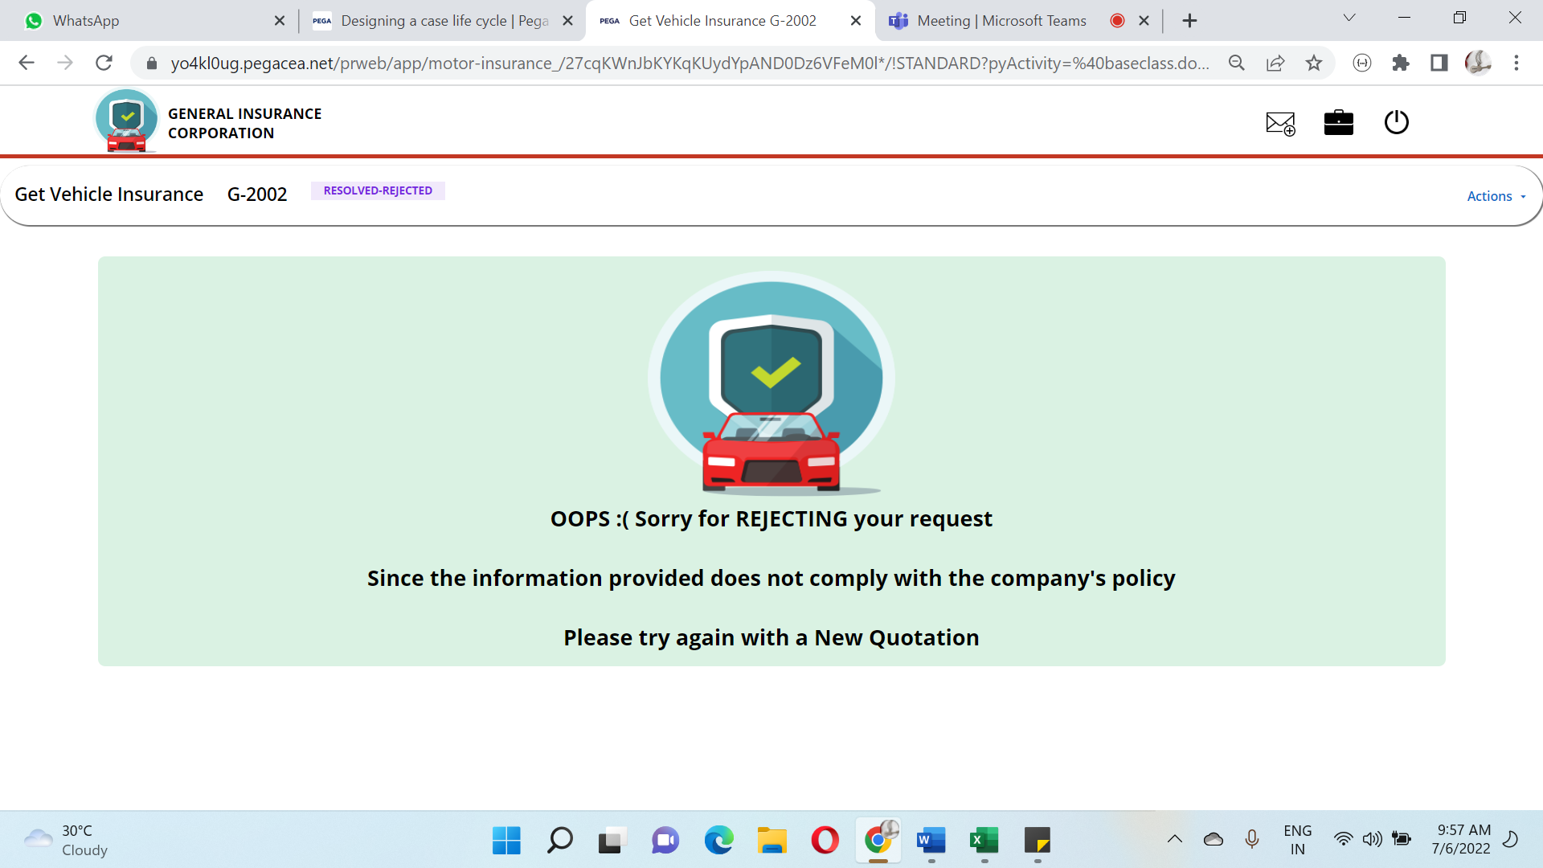

**CASE ATTACHMENTS:**

**Automatic Rejection Mail:**

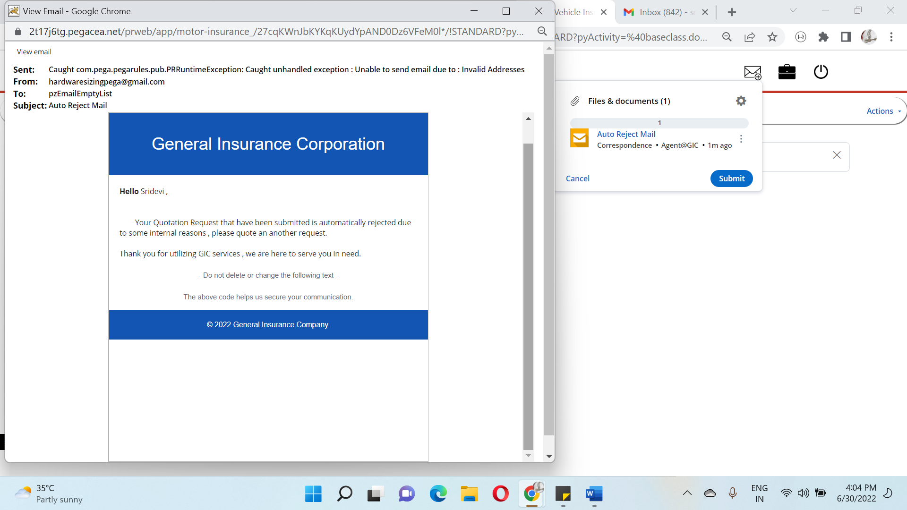

**EVIDENCE 4: AGENT REJECTION**

1)First Login through the Agent portal and fill in the data collection multistep form



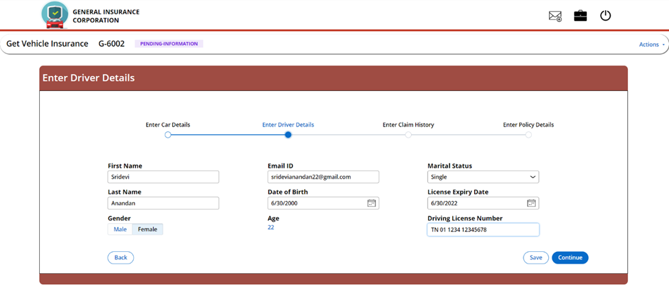



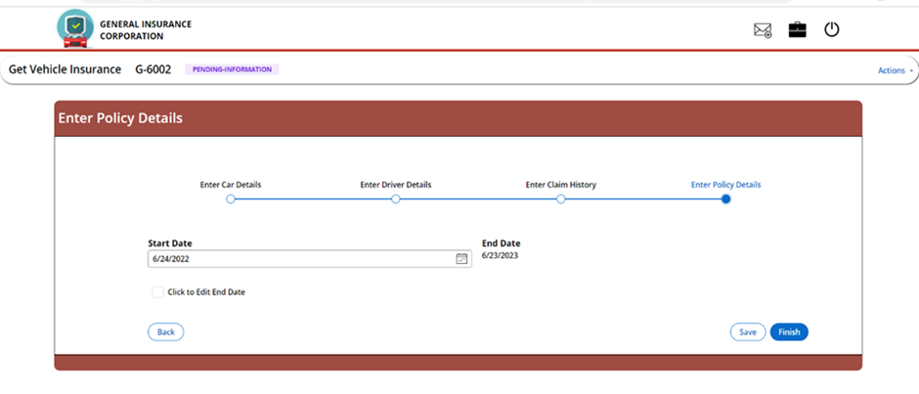

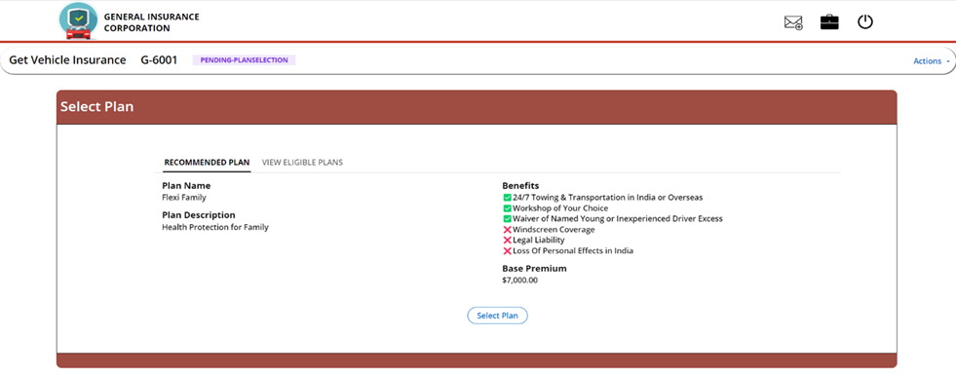

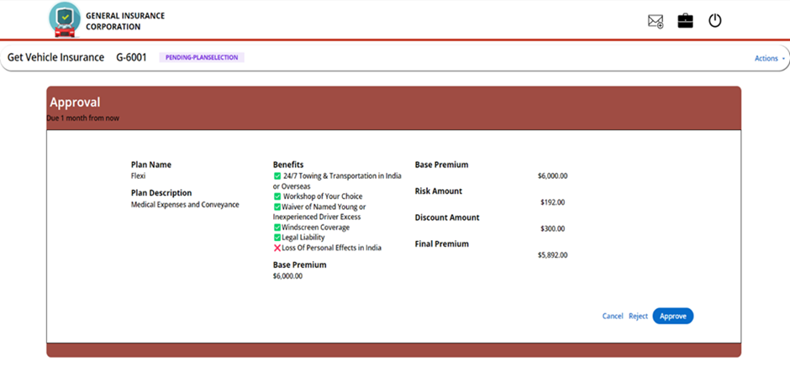

2) Now the case will cancel and a confirmation note is shown to the agent.

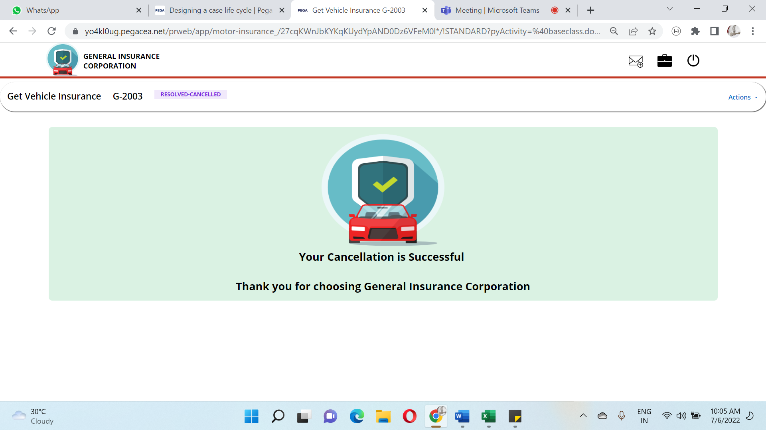

**CASE ATTACHMENTS:**

**PLAN CANCELLATION:**

